1. Watch terraform-06 video.  
   Done.
2. Execute the script shown in video.  
   For terraform modules:   
   why modules are used **To create multiple things with same configurations for different environments.** (Terraform Directory and Testing)  
   Created a folder with name “Terraform Directory” which has main.tf and variables.tf.   
   main.tf:  
   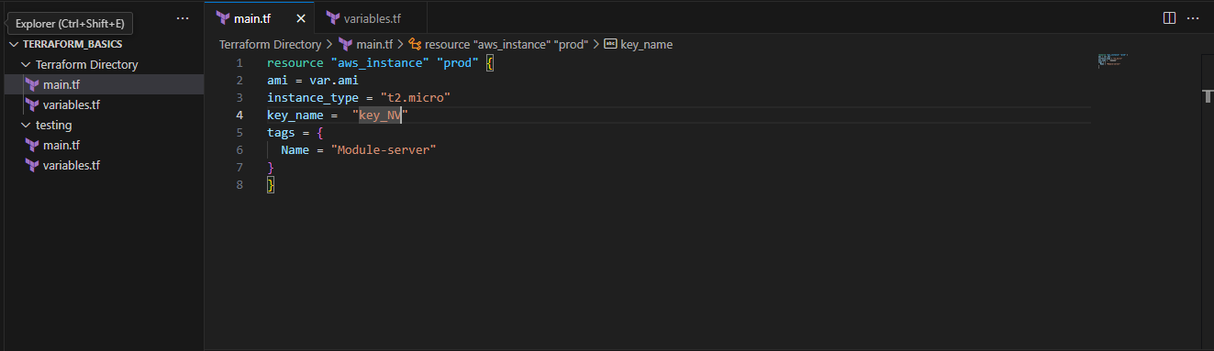  
   variables.tf:   
   (Instead of passing the variables ami I have passed it in the module block ami{in testing})  
   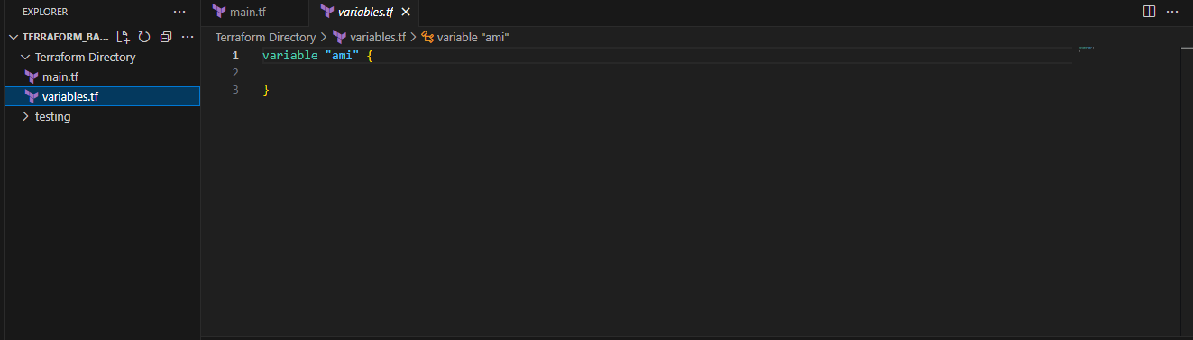  
   Another Sub-Directory as “Testing”: (As we have the instance configured in Terraform directory so we are redirecting to that file with source file)  
   main.tf for testing: {.. means TERRAFORM_BA&/terraform_directory means inside it main.tf take from it }  
   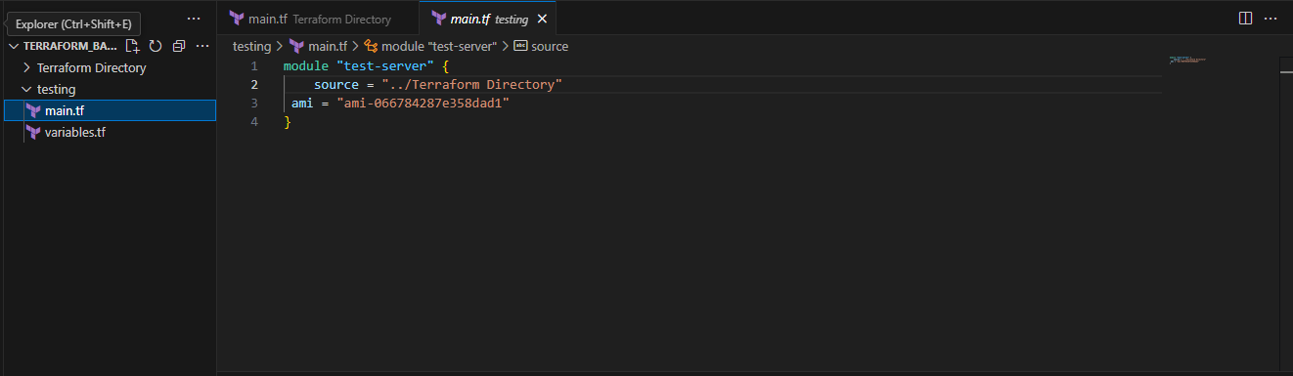  
     
   variables.tf:  
   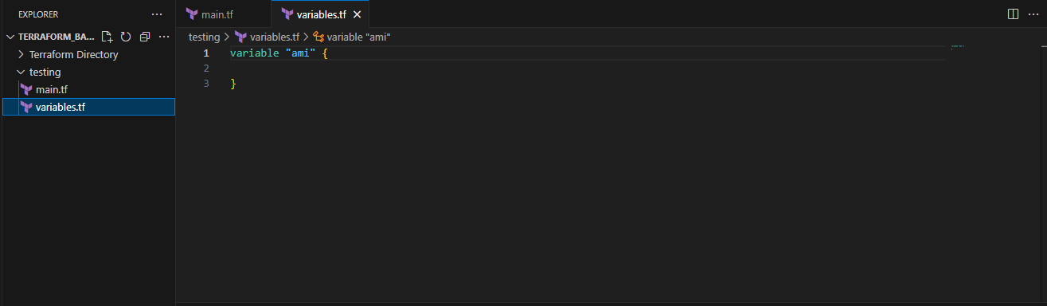  
   Changed the directory to the testing directory and initialized terraform:  
   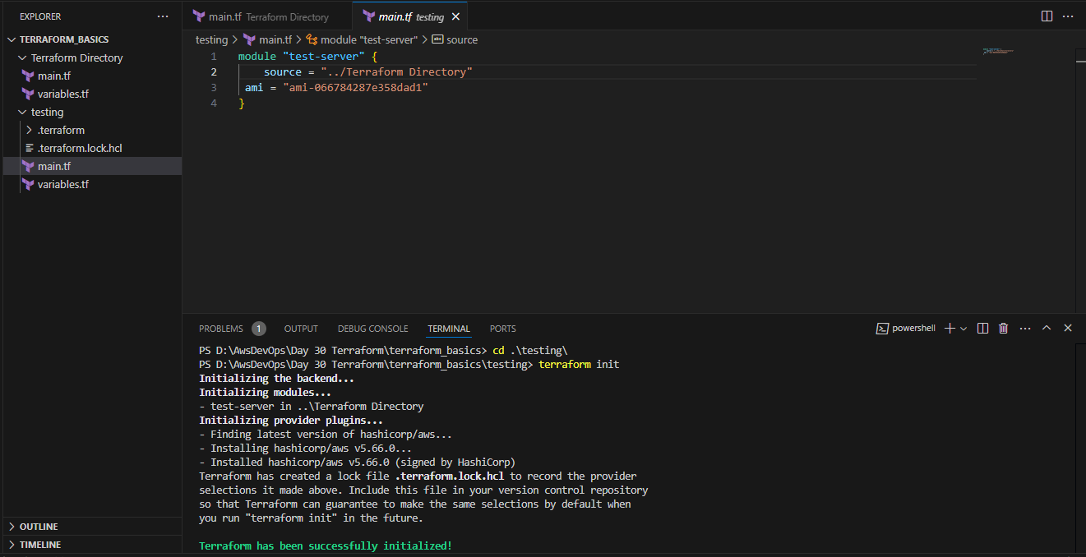  
   Terraform apply for executing our script: As I have highlighted the place this calling from that resource and executing the script.  
   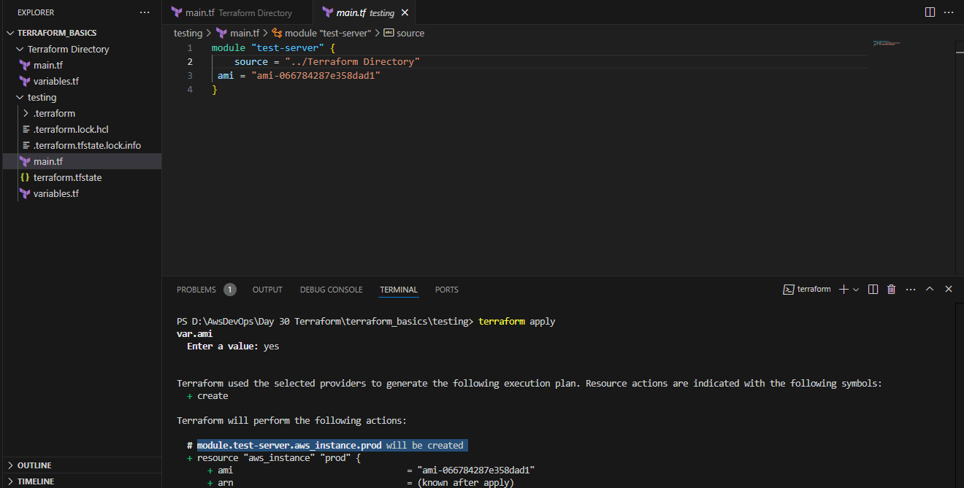  
   cross checked on aws console:  
   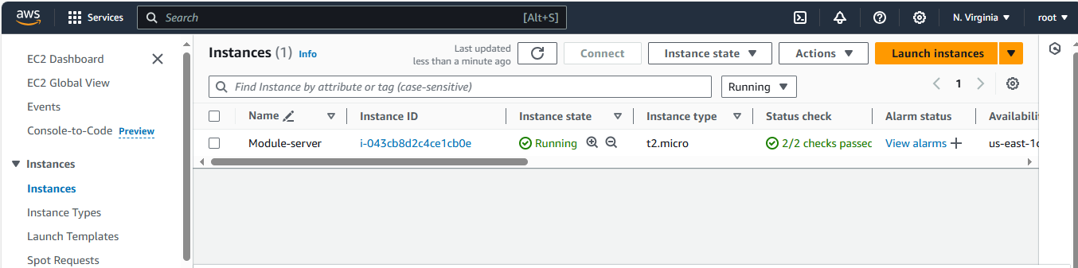  
     
     
     
     
     
     
     
     
     
     
     
     
     
     
     
     
     
   Created another sub-directory by name Production:  
   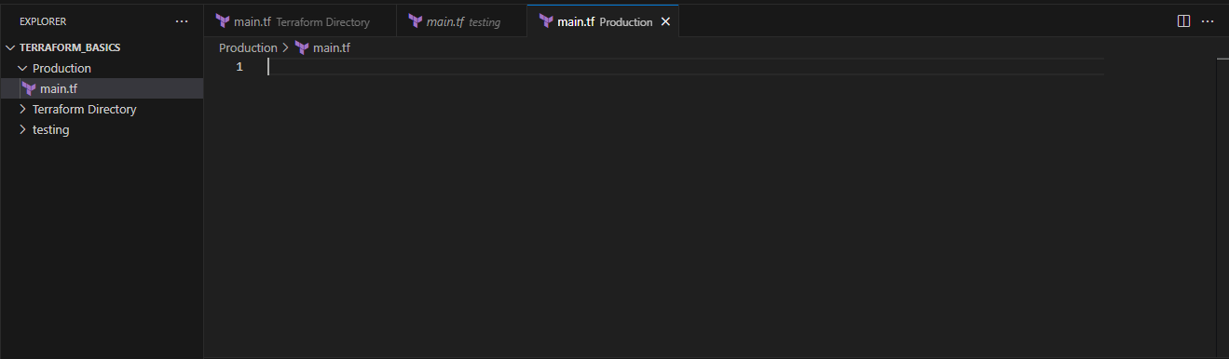  
   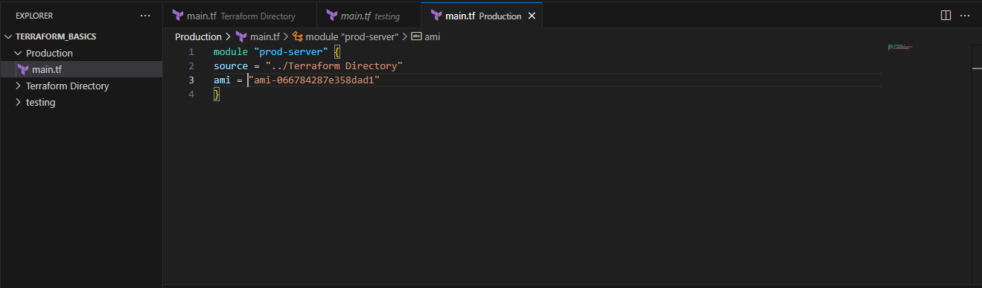  
   created in production:  
   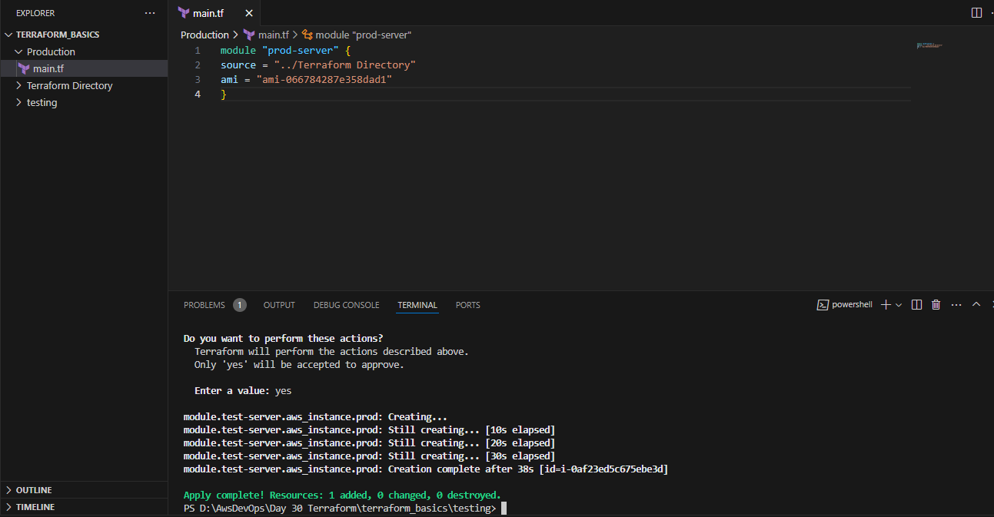

checked in aws console:  
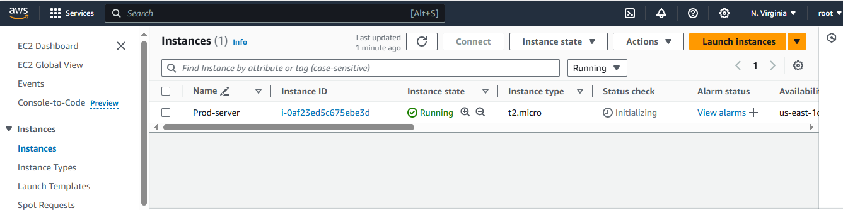

1. Provision ec2,s3 and vpc using Terraform modules.  
   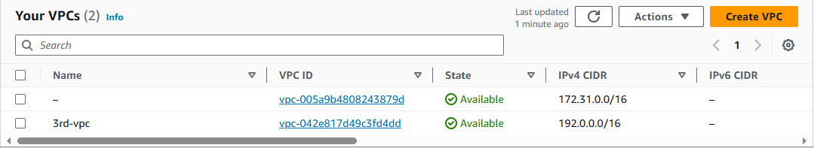  
   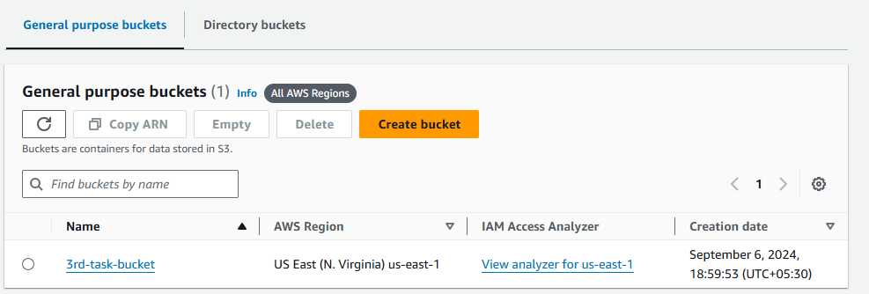  
   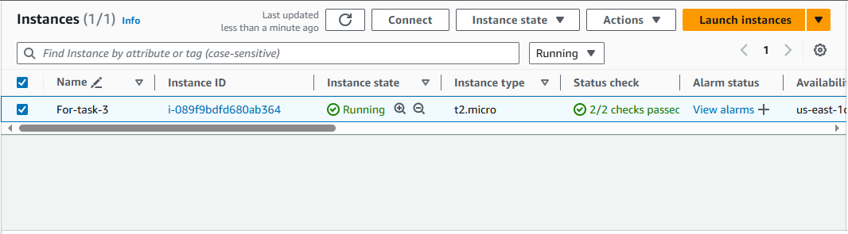  
   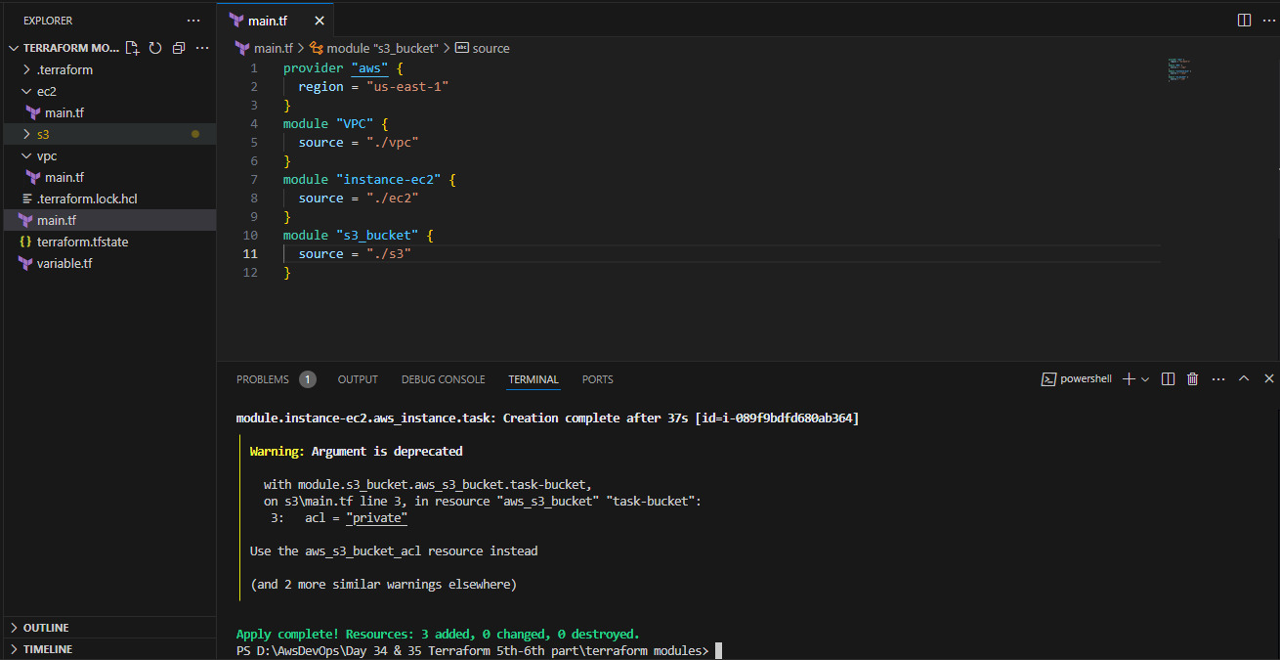

VPC:  
main.tf:  
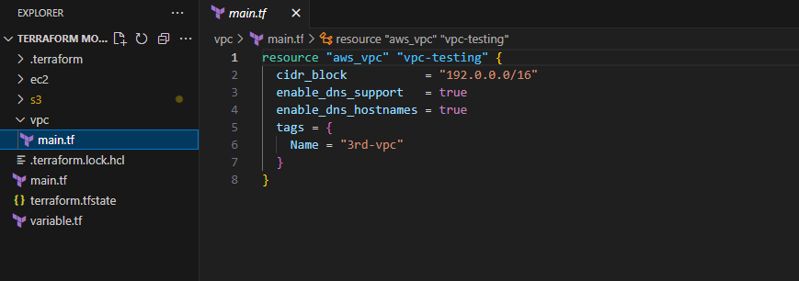  
EC2:  
main.tf:  
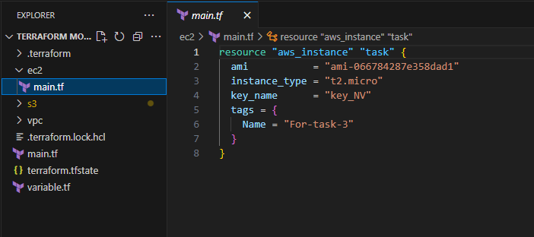  
S3:  
main.tf:  
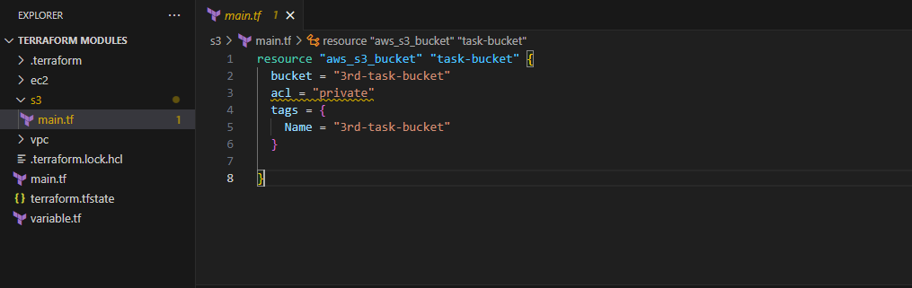

1. Provision ec2 for 3 different environments (Dev, Staging and Prod) using terraform workspaces.  
   Firstly I have Created Main.tf:  
   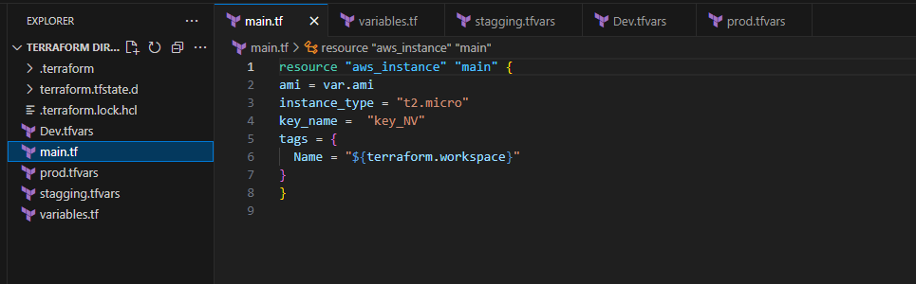  
     
   Then variables.tf:  
   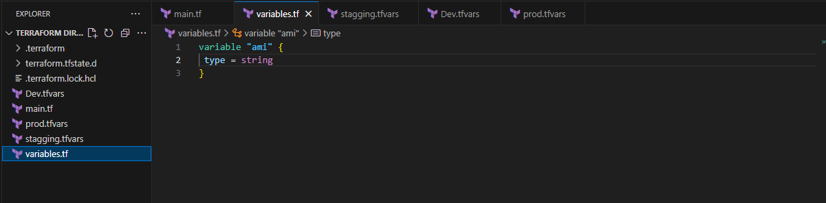  
   Created a variable file for Prod environment prod.tfvars:  
   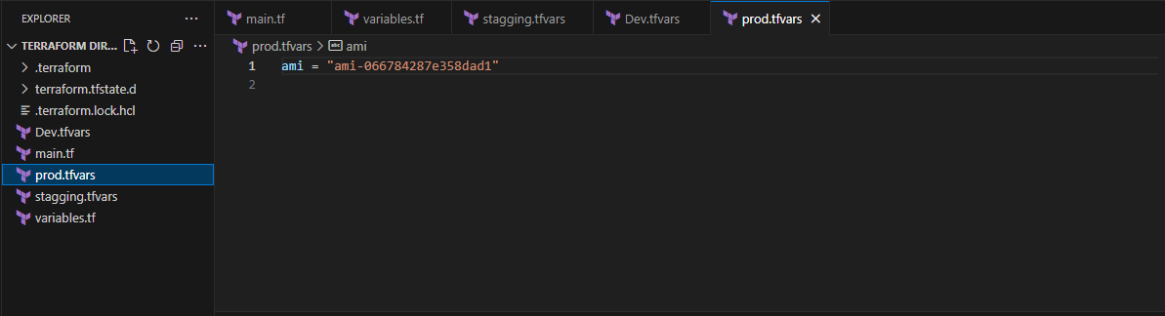  
   for staging Environment stagging.tfvars:  
   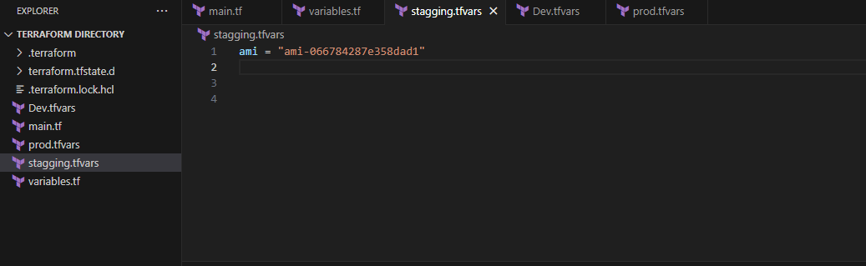

For Dev Environment Dev.tfvars:  
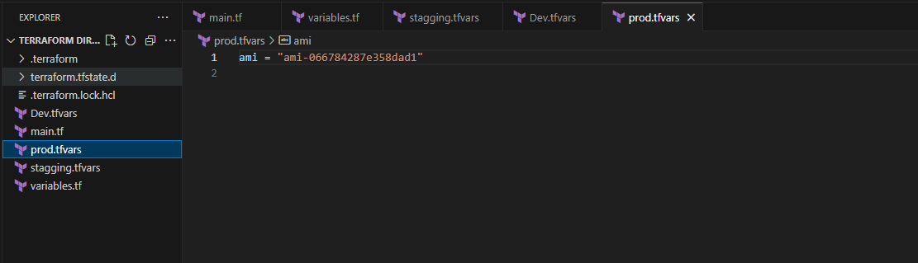  
Once done with creating the variable files for each environment create the workspace environment for

Each stage:

terraform init

terraform workspace new Dev

terraform workspace new prod

terraform workspace new stagging

Once done with this we need to switch to appropriate workspace and configure with its .tfvars file

terraform workspace select Dev

terraform apply -var-file="Dev.tfvars"

terraform workspace select prod

terraform apply -var-file="prod.tfvars"

terraform workspace select stagging

terraform apply -var-file="stagging.tfvars"  
  
Cross-checked the instances in the aws console: 